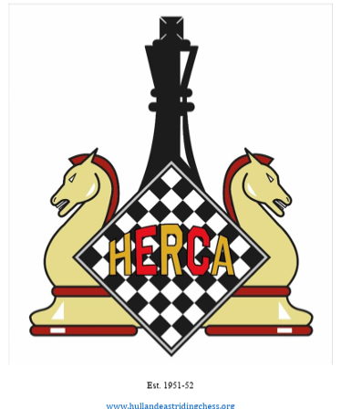
HERCA
HULL & East Riding Chess Association
Registered charity (No. 1155858),
SUPPORTING YOUR CHESS ACTIVITIES
Courtesy of the Hull and East Riding Trust, and the James Reckitt Trust

WHAT HERCA CAN OFFER
- Financial Support and equipment
- Chess coaching and event organising expertise
- Chess contacts and volunteers throughout East Yorkshire
- Help with promoting & marketing of your event

WHO CAN SEEK SUPPORT FROM HERCA?
- Anyone organising any chess activity or event in the Hull and East Riding area may apply for support from HERCA

HOW DOES HERCA DECIDE WHAT IT CAN SUPPORT?
HERCA is whose objectives are:
- The advancement of amateur sport by promoting the game of Chess for the benefit of the residents of Hull and the East Riding
- The provision of facilities for the learning, teaching and playing of chess for the benefit of the Beneficiaries with the objects of improving conditions of life.
Where we have the resources to do so, we seek to support any chess events or activities in-keeping with these objectives

HOW TO APPLY FOR SUPPORT?
- Please complete the form below [or at this link: TBA]] and return to: HERCA General Secretary, Keith Porteous at keithportousinhull@yahoo.co.uk

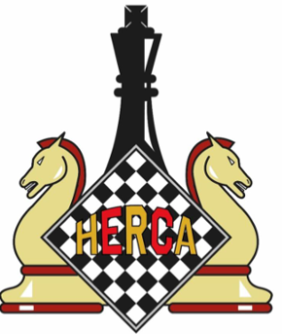 HERCA Support
Hull and East Riding Chess Association – registered charity number 1155858

For this year HERCA is fortunate to have available the sum of £4500, additional to normal recurrent funding, courtesy of two grants; £2500 from the Hull and East Riding Trust, and £2000 from the James Reckitt Trust. This document outlines the principles and practice of consequential HERCA support for local chess initiatives for the year 1/6/26 to 31/5/27.

- Any individual or organisation in the Hull and East Riding region is eligible to bid for funds from the HERCA SUPPORT budget. In addition to funding, advice and other non-financial support can also be requested. Potential bidders should be aware, also, of the English Chess Federation’s Grassroots Fund, which can be found at ECF Grassroots Fund – English Chess Federation.

- HERCA SUPPORT is aimed at developing and promoting the game of chess in the region, and bids will be assessed according to how well they fulfil this aim. The Association is particularly keen to promote collaboration between organisations involved with chess in the region, although such collaboration is not a pre-requisite for a bid.

- Bids should be submitted, using the accompanying form, to the General Secretary, Keith Porteous (keithporteousinhull@yahoo.co.uk). Anyone contemplating making a bid is welcome to seek initial advice from the Gen Sec.

- The deadline for submission for the first tranche of funding is May 17th. Subsequent deadlines for the second and third tranches will be October 11th and January 31st, 2027.

- The received bids will be assessed by the HERCA Executive Committee, according to the criteria:
- The extent to which they fulfil the HERCA charitable aims.
- The likelihood of planned activities being successful in their objectives.
- The balance of costs and expected benefits.
- The likelihood of planned activities being able to continue without further funding.

- Bidders can expect to know if they have been successful within three weeks of the bid’s submission.

- A successful bidder can expect support, in terms of advice, guidance, and relevant expertise, from HERCA, during the period of their activity. A trustee or other HERCA officer will be allocated to help guide and support the project. In return the successful bidder should acknowledge the support of HERCA it its project.

- A successful bidder will need to provide HERCA with a short report after the completion of the activities, outlining their successes and things they have learned through their work.

HERCA - Hull & East Riding Chess Association

Chess Activities and Events in Hull & East Riding
Application for Support

Name of individual person, or organisation, making this application

- Short name or description of the chess event or activity (Maximum 10 words)

- Names of lead organiser(s) with contact details

- Fuller description of event / activity

Please include:
- Dates/duration of proposed event or chess activity
- Details of collaboration with other organisations, if appropriate
- Expected or desired participants in the event/activity (e.g. numbers; age group; target area/location/cohort they will be drawn from)
- Proposed or intended location or venue(s)
- Description of the chess event or activity that is proposed.
- Other information you feel relevant to your application

- What benefit do you think the event can bring for its participants and/or the wider community of residents of Hull and the East Riding?

- What support or assistance are you applying for from HERCA?

Financial support

Advice and guidance from HERCA

Other support

Form completed by:
Name: ______________________________________ E-mail: _______________________________

Date: _________________________ Telephone number: ____________________

Please submit the form to: Keith Porteous (General Secretary), keithporteousinhull@yahoo.co.uk

