
Hull and East Riding Chess Association (Registered Charity 1155858)
ECF LMS User Guide for Team Captains and Club Representatives

Contents
Introduction 2
Requesting an LMS Account 2
Logging into LMS 3
Editing your LMS contact details 3
Being an “Owner” of a club 4
Entering Match Results 4
Adding New Players to LMS 6
Defaults 8
Verifying a match result 9
Results in dispute 10
Change History 11

Introduction

This guide is provided by the Hull & East Riding Chess Association. It aims to offer step-by-step instructions for members on how to enter and verify match results for the HERCA league(s).

Requesting an LMS Account

If you need to be able to enter match results or want to run a competition, you’ll need to have a login to LMS. To request one go to https://lms.englishchess.org.uk/lms/contact/request_a_login_id . This brings up the following page:
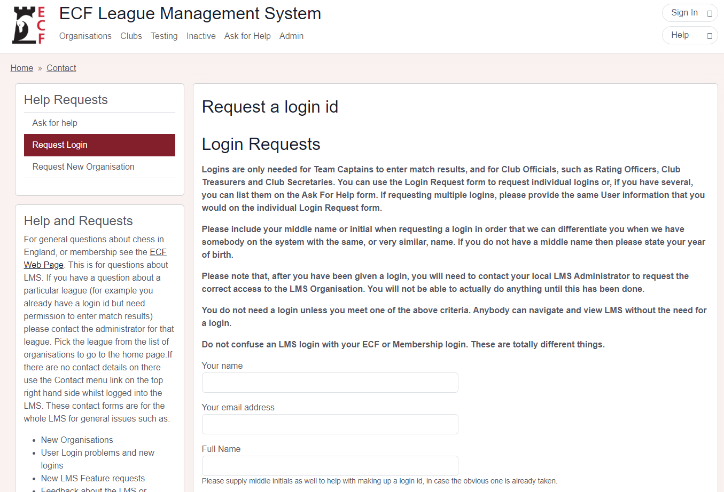

Enter your details and press on the “Send Message” button at the bottom of the form.

You should receive a Welcome email with your LMS login details within a few days. If you haven’t received it, check your SPAM/Junk mail folder. If it's not there, use this contact form for assistance:
https://lms.englishchess.org.uk/lms/contact

Logging into LMS

Once you’ve received your login details, go to: Log in | ECF League Management System

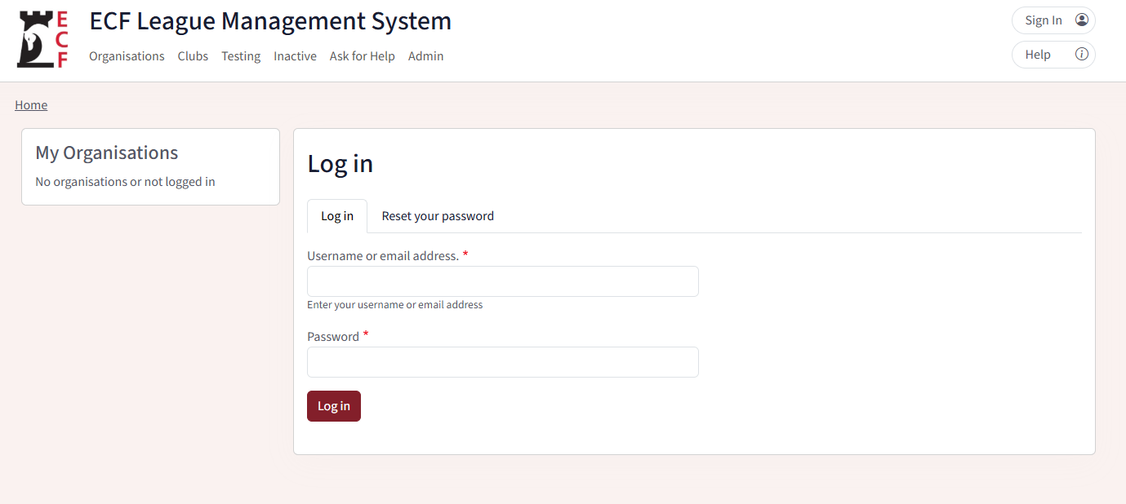

Enter your supplied username and password and press the “Log in” button. This will then sign you into LMS.

Editing your LMS contact details
Once signed in, click your username in the top right corner and select “My Account.” Then, click the edit tab to update your contact information.

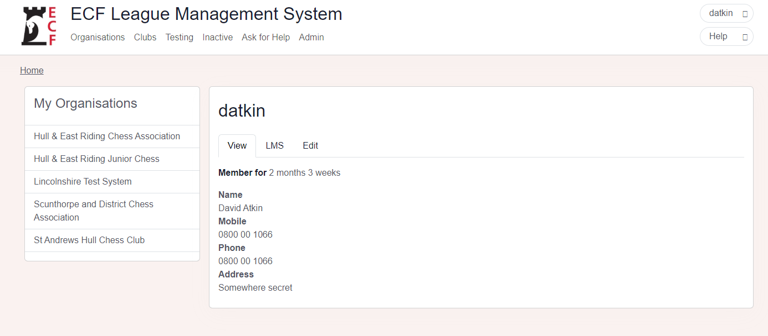

Being an “Owner” of a club

To be able to enter match results, you’ll need to be an “owner” of a club.

To become a club owner, email the League Secretary with your LMS ID and the club name(s). They will then give you the permission to enter results.

Once you’ve been made owner of your club you can see your list of your clubs by clicking your username in the top right and then clicking “LMS Access”.

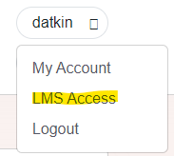

Entering Match Results

Once you’re an “owner” of a club, you can enter match results.

If you are the Home Captain for a match, you are responsible for completing the match card.

After logging into your account. Click your username on the top right and select “Enter Results”

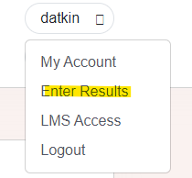

You’ll then be shown a list of fixtures under “My Fixtures” which have not had any scores entered:

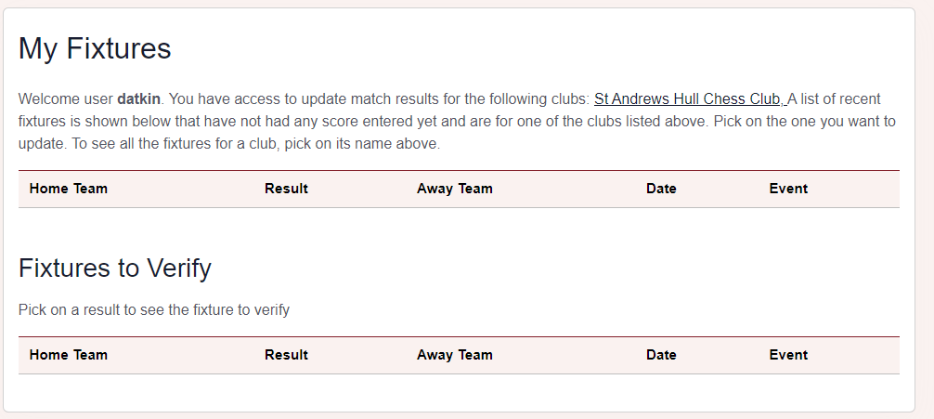

Find the appropriate match that you’d like to enter the result for and click on it. This will take you to the match result screen. Make sure that you are on the “Match Result” Tab and you will see something like the bellow:

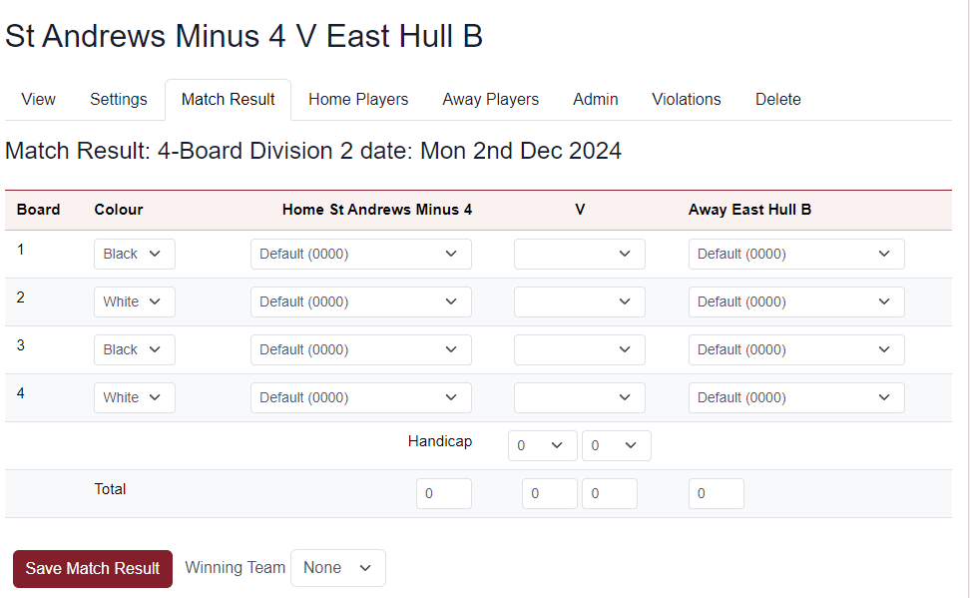

Enter the match result using the drop downs, select:
1) The players for each of the teams
2) The board result in the column designated “v”
3) The handicap, if applicable.

You shouldn’t have to change the board colours. If you do, please inform the league secretary.

Click on “Save Match Result”. This will then show you the saved result:

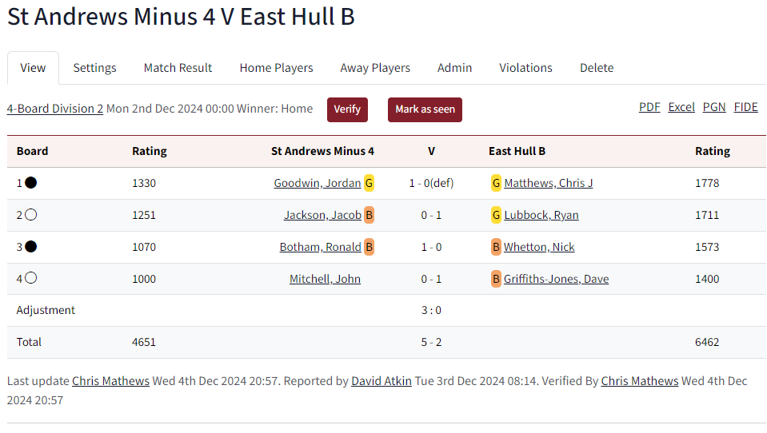

Adding New Players to LMS
If your team has played a new player which is not listed on LMS, do the following:

- Select the players name as "New Player (0000)". This serves as a placeholder until that person can be added.
- Put in the “Comment” box information about the new player that will enable the League Controller to find them in the grading list.

- Also provide in the “Comment” box the Estimated grade that has been agreed with the League Secretary.
- For example, if the player is John Smith, we need to know which John Smith, so the grading points go to the correct person
- Have they had a grading before, have they just moved to the area?
- For new junior players it is desirable to have date of birth, but it is better to email or use the contact form for this sensitive information rather than putting it in the match card comment.

For example:

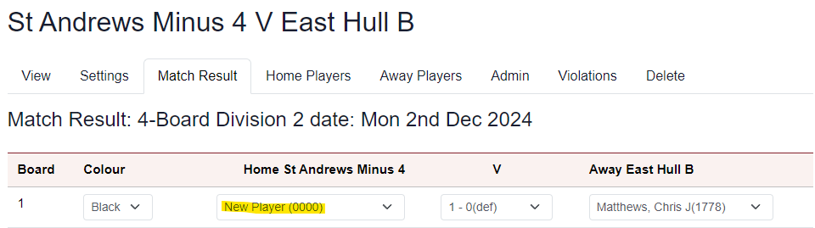

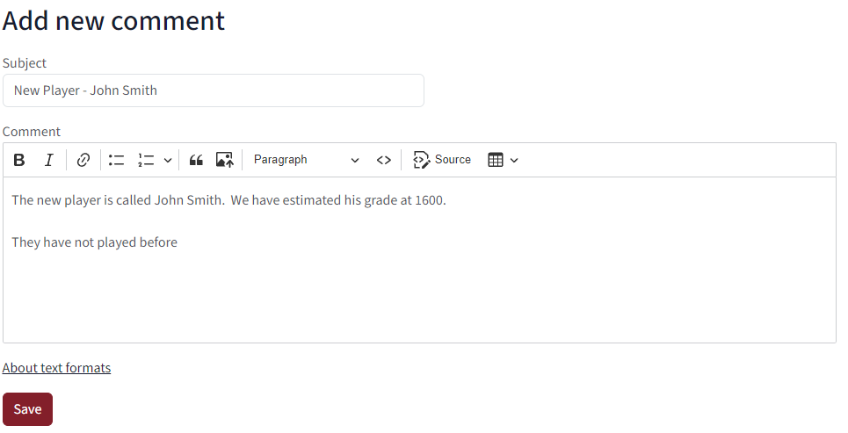

Defaults
If a player listed on the match sheet fails to make an appearance and the game is defaulted, do the following:

- Select the player’s name
- Select for the result “1-0 (def)” if it was the away player or “0-1 (def)” if it was the home player defaulting. E.g.:

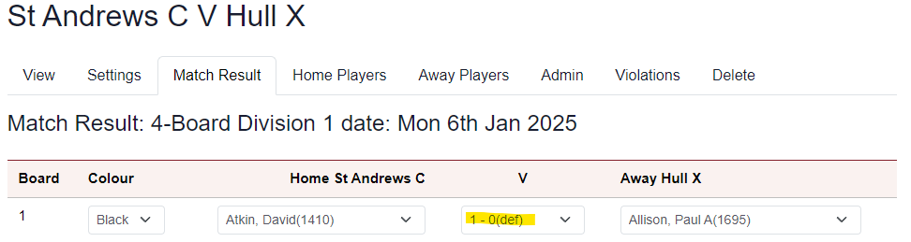

If it is known beforehand that a board is defaulted:

1) Leave the player as “Default (000)”.
2) Select for the result “1-0 (def)” if it was the away team defaulting the board or “0-1 (def)” if it was the home team.
For a double default, select “0-0” for the board score. E.g.:

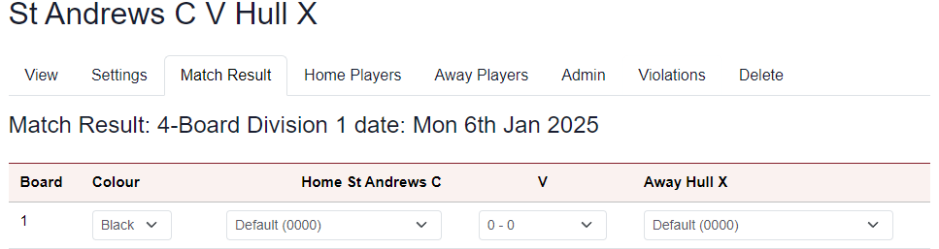

Verifying a match result
As the visiting captain you are responsible for verifying the match result.
Steps:
1. Login to LMS
2. Click on your profile name at the top right and select “Enter results”
3. Click on the appropriate match in the “Fixtures to verify” list:

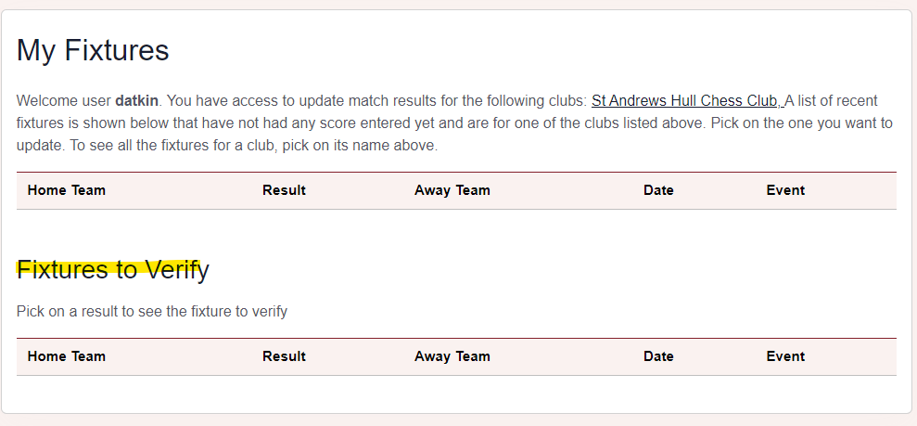

If you’re happy with the result, click on the verify button at the top. It will then be shown as being verified:

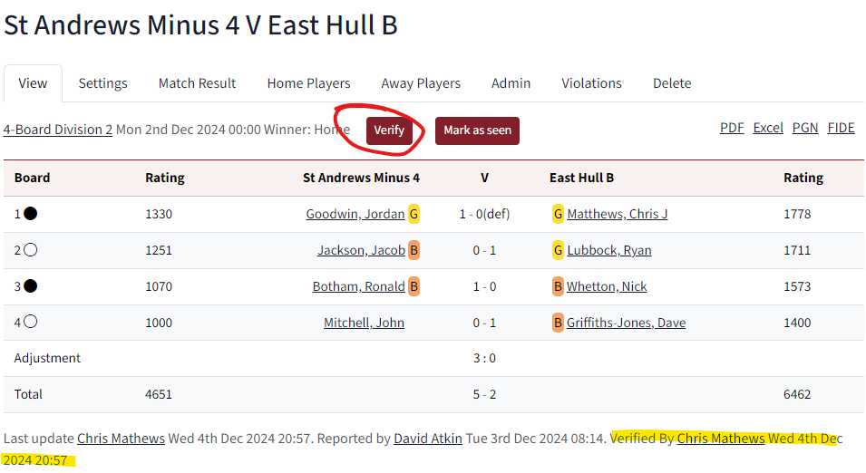

Results in dispute
If you are not happy with the result, instead of clicking on “Verify” add a comment to the League Controller by:
• Providing a subject
• Entering an explanation regarding the dispute and
• Press the “Save” button

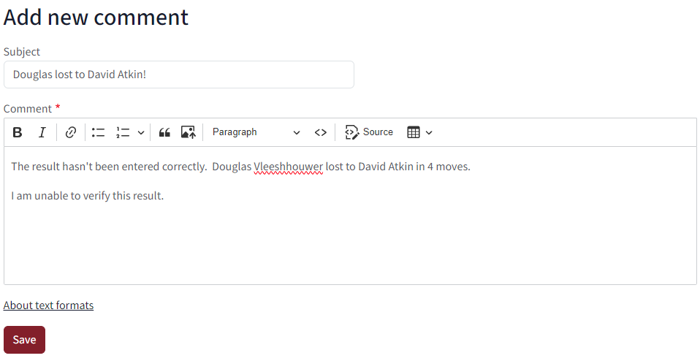

When the League Controller logs in to LMS the next time, he’ll see a note at the bottom of his screen, notifying him of the “event”.

Change History
Issue | Date | Summary of Changes | Author
0.1 | Mar 2018 | Initial Issue | DV
0.2 | Apr 2018 | Added instructions on how to manage the u125, u165 and Peter Hughes competitions | DV
0.3 | Oct 2018 | Added instructions about defaults | DV
0.4 | Aug 2022 | Added clarification about requesting a new account | DV
2.0 | Jan 2025 | Document re-created due to LMS interface upgrades | DA/DV

